II. CENSUS INSTRUCTIONS

INSTRUCTIONS FOR BIRD CENSUSES ON PALMER LTER CRUISES

Modified 2019 by MR

Modified Nov 2021 by MC + D&MR, 2023 by AN&MR

*The LTER cruise has many different science groups conducting their individual research at the same locations along a standardized sampling grid. This collaboration links oceanographic, biological, and physical data to determine the effects of climate change on the Western Antarctic Peninsula. We are the seabird/mammal survey component along this grid, and we record all our survey data in a database on a Samsung tablet.*

The ship will follow the LTER survey grid along the Western Antarctic Peninsula (*Fig. 1*), which contains a series of **grid stations** and **underway stations**. These grid lines follow a pattern from inshore to offshore in order to capture processes affected by land and ice melt, out to the open ocean, beyond the continental shelf. The grid also contains ‘**process study**’ sites in areas of high interest (ie. there is always one in Palmer Deep, these are usually based along submarine canyon locations). Ask for maps from the Chief Scientist at the beginning of the cruise to get a good idea of the plan for this year’s cruise. There are small changes and shifts that occur every year, although the majority of the grid is followed consistently (600 line to 100 line). Sea ice is a big factor that plays a role in how far we are able to make it down south.

**Grid station:** A point on the survey grid where three operations usually occur: (a) optical cage/CTD, (b) 2 m net tow, (c) 1 m net tow. The ship is either stopped or going <5 kts during these ops. Therefore, we conduct stationary surveys during these (one per operation) for a total of 3 stationary surveys per grid station. If there are multiple 1m or 2m net tows, conduct surveys for each net tow event… meaning you may wind up doing more than 3 surveys at a single grid station.

**Stationary survey protocol**: Census area covers a 360° view around the ship. Record any birds or seals sighted within 300m, and any whales within 900m. Stationary censuses are 15 minutes in duration. You will start and end your survey with a stern count (described below). Stationary censuses are intended to be “snapshots” of what is in the area, so any animals believed to have followed the ship to the station should be excluded (only included as stern counts).

# Stern count: The first and last species entry should be a stern count (SC) at time 0 (beginning) and end minute+1 (end time) – noting all animals that are followers. Be sure to check the box for “Stern Count Start” or “Stern Count End” on the tablet. Don’t count the same animal twice but you can count the same individual twice between surveys/transects.

# Underway station: An underway station is between grid stations on a cardinal line (NOT transiting between lines, i.e. from the 600 line to the 500 line). One operation usually occurs at an underway station: water sampling. The ship should be underway at this time, going >4kts. We conduct a transect survey during this time.

**Transect survey protocol:** Census area extends 300m from the ship within a 90° arc from the bow to the wing of the observer’s side (900m for cetaceans). You will start your transect survey once the ship sets off toward it’s next station (either a grid or underway station), and finish your survey when you are halfway between waypoints. Each station is typically 10nm apart, so you may need to watch the TV screen in the bridge to see when you’re ~5nm away from the next station… then you know to stop your transect survey. The transects are around 30 mins when ship speed is going 10 knots, but the survey time can change based on ship speed. They are conducted from the forward port corner of the bridge (LMG) or forward starboard corner of bridge (NBP, because you can see stern easier), unless glare is prohibitive. Generally, the side doesn’t matter as long as it is consistent. You will start and end your survey with a **stern count**.

Transect surveys are only conducted when the ship is moving faster than 4 knots (generally at 9-10 knots). One exception to this will be when the ship comes into ice. Bird aggregations can change rapidly at ice edges and should be noted if on a survey line even if the ship slows down. If moving at an average of 4-5 knots through ice, continue to survey. If the ship is backing and ramming to move through ice, the survey effort should stop. If the ship is moving less than 4 knots in ice perform a stationary survey at stations along the cardinal lines. Each transect is treated as an independent sample. Thus, do not exclude animals you believe were recorded on previous transects (these will be included in stern counts). These are invariably ship followers, which will be omitted from analysis anyway.

The below schematic is to help show survey time in relation to different stations. If there are two underway stations in a row, use this same survey spacing.

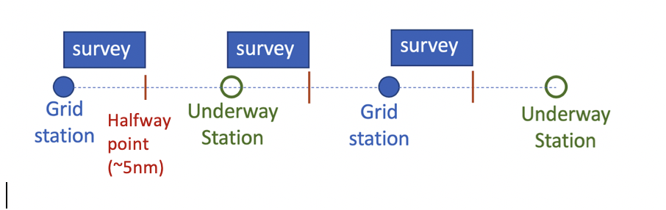

**Cliff notes:**

**Stationary surveys**: 360° view, 300 m for birds, 900 m for whales; 15 minutes, at time of CTD or optics, 2 m and 1 m net. (usually 3 stationary census per station; or more if multiple 1m or 2m net tows are conducted)

**Transect surveys:** 90° view, 300 m for birds, 900 m for whales, while underway between grid stations (from grid station to halfway to next grid station - roughly 5nm or ~30 minutes)

**MATH! Calculating 300m and 900m distances**

The 300m and 900m marks can be determined using the equation:

d = h(bv – hc) / bh + vc

We want to solve for c; c = (dbh-hbv) / (-dv-h2)

**d**: distance from the observer to a point on the water (300m or 900m)

**b**: distance from the observer’s eye to the upper jaw of a caliper held in front of him/her at arm’s length (use a tape measure to get this distance, differs by person)

**h**: height of the observer’s eyes above the water (12m for LMG bridge, 17.7 for NBP)

**v:** distance from the observer to the horizon (i.e. v= 3838_h or written as v=3838(h1/2), (13295 for LMG, 15824 for NBP)

**c**: vertical distance, measured with the caliper, from the horizon to the point on the water (Heinemann 1981). All units in meters, but easiest to convert final value to mm for calipers.

For example, c = 19.5 for 300m for Allie. In other words, with the caliper set at 19.5mm and held at arm’s length with the upper jaw at the horizon, anything on the water at or below the lower jaw would be within 300m. c= 6.2mm for 900m for Allie :) For a person with longer or shorter arms, the caliper setting would be wider or narrower, respectively. With practice, discerning the 300m and 900m marks will not necessitate calipers.

Don’t want to carry calipers around the bridge? Try this:

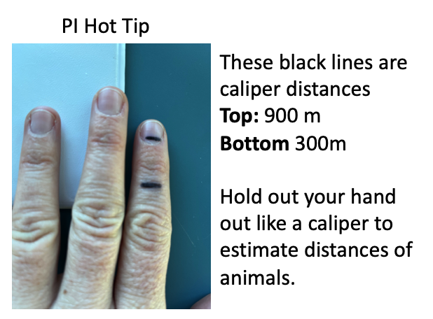

# DATUM FIELDS

**Cruise**: Enter the year and the number of the cruise as a four-digit number (e.g., 0401).

**Yr/Mo**: Enter the year and month as a four-digit number (e.g., 0401)

**Station Number(s)**: Enter the designation(s) of the origin and destination of the transects or the station for stationary censuses. Along cardinal lines, stations have a three-digit line designation followed by a period and a three-digit station number (e.g, 500.060). Other stations, however, have designations such as ‘B’ or Lemaire’ or ‘617.5.035’. If unsure of the station number, check the daily schedule or the bridge log or just ask someone.

**Event #**: This will be obtained from the bridge log. Additionally, as we are on the bridge during observations, we sometimes enter the event number information into the bridge log (but this is the job of the mates). An event number is created and given to every science operation (Optical cage, CTD, 1m net, 2m net, etc) as well as **every survey you conduct!** Call it “Birder Event”. It’s important to make a new Birder Event immediately when the ship starts transiting from one station to the next to accurately record the time and other data for when the transect begins.

Diet samples and colony census trips get an event number as well (“Birder event”).

**GMT**: Greenwich Mean Time, three (summer) or four (winter) hours ahead of ship time, which is Chilean time. Enter the Julian date, hour, and minute of the starting time of each transect or census (e.g., 2010515; 3 digits for julian day, 2 digits for hour, 2 digits for day).

**Transect Time**: Enter the length, in minutes, of each transect. Transects should be 15 mins (stationary) and around 30 mins (transect) in length. Typical trips between stations along cardinal lines take about an hour and are covered by one 30-minute transect from the start of a grid line waypoint to the midpoint between grid stations. If the ship slows down during transit, due to ice, etc, the transect survey can be longer until the midpoint is reached. This can be viewed on the ship computer (time/distance to waypoint), and does not have to be exact. Any time the ship makes a major change in heading, a new transect should begin (this rarely occurs). Stationary censuses are always 15 minutes long when the ship is going 0-3 kts.

**Speed**: Enter the average ship speed, in knots, during each transect. Can ask the mate, the time at which the event begins does not always represent the speed of the vessel during transit.

**Latitude / Longitude**: Enter the coordinates at the beginning and end of transects or at the station. The beginning coordinates are found on the bridge computer when your event is entered (i.e. in the event log). It is easiest to get the end coordinates of a transect survey by starting a new event on the computer, after your stern census end, and deleting it when you’re finished.

**Sea State**: Record the wind speed on the Beaufort scale (print out this scale!). The wind-speed reading is affected by movement of the ship, so take the reading immediately before the transect.

**Habitat**: Record the habitat according to the following coding system.

1. Open (at least three nautical miles from land and large icebergs)
2. Berg zone (within three nautical miles of large icebergs
3. Irregular MIZ
4. Band MIZ
5. Pack

**Cover**: Record the ice cover within 300m of the ship in octas (eighth; 8 octas = 100% cover). **Bergie bits are not considered ice cover.** There is a NOAA sea ice guide in the Birder Bible Binder (Note: NOAA records ice cover in 10ths).

**Ice Type**: Record the ice type according to the following coding system. Bergie bits=1

1. None
2. Pancake
3. Brash
4. Floes
5. Sheet

**Ice Color**: Record the ice color according to the following coding system. Bergie bits=1

1. None
2. Clear
3. Green
4. Brown (on the underside, resulting from ice algae)

**Depth**: Record the water depth in meters as registered on the bridge monitors (or in event log).

**Time**: Record the minute of the count during which each animal is detected. A stopwatch is helpful especially when attached to a clipboard. On transects, record any animals seen off the stern immediately before (using minute “0”) and after (last minute + 1) the count. Do not count anything more than once during a given transect (including the stern counts).

**Taxa** (= Taxon): Record the four-character alpha code of each taxon observed using the codes given in Table 1. We have a dropdown menu in the data form now, yay!

**Number**: Record the number of individuals in each observation.

**Link**: Use the link field to indicate animals that are interacting with one another or are attracted to a common resource. Examples of links are kleptoparasites and their hosts, mixed species flocks and feeding assemblages, penguins and seals together on ice floes, animals joining others of the same species during a later time period, or animals belonging to same-species assemblages but exhibiting different behaviors. Each linkage within a census should be given a unique number beginning with ‘1’. Animals attracted to the ship should not be given link numbers. It is not necessary to write ‘0’ for unlinked animals. Note: Linkages are relatively rare; most censuses will not have any.

**Behavior**: Record the behavior of each animal or group according to the following coding system.

1. Attracted to the ship (following on transects or circling on stationary counts). An animal that becomes attracted after it enters the census area should be given the code for its behavior prior to attraction.
2. Flying directionally. Note that a bird flying in a seemingly non-directional pattern but in a more-or-less consistent overall directions should be given this code. Use a 360° wheel with 15-20° marking to aid with entering the direction of the flight. This heading is the birds true heading, not its heading relative to the ship.
3. Flying non-directionally (no consistent overall direction).
4. In or on the water but not moving in a discernible direction.
5. Resting on ice.
6. Swimming directionally (use the same wheel as in flying directionally).
7. Feeding
8. Rafting (used for penguins only).

If an animal exhibits more than one behavior, record the highest-ranked behavior according to the following ranking system (from highest to lowest): 0 – 6 – 7 – 2 – 3/4 – 1/5. The rationale of this system is that behaviors indicative of feeding are ranked higher than others; however, animals drawn into the census area by the presence of the ship receive the highest ranking because they probably will be excluded from the analysis.

It often takes some time observing animals to determine the correct behavior code; and meanwhile other animals could come and go unnoticed (and thus, not recorded). So, do not spend too much time trying to figure out the appropriate code. Most animals will be given code ‘1’.

**Now you are ready to survey. Here is a helpful list of to do’s:**

1. Attach directional wheel in correct direction (check ship heading) and timer to clipboard and get tablet. Get Binos.
2. Mate will add the event to the event log, which can be accessed to fill out table header information (this can be done before or after survey begins). Spending too much time entering the header eats into survey time, so be mindful so it is recommended to complete the header information after the survey. Assuring that all fields on the event log are being auto populated when the event is created allows you to choose when you fill out the header, allowing you to survey at the correct time. Consult with IT if the event log is not auto populating.
3. Start your timer at the time that the event begins so that the meta data in the event log is consistent with when we are sampling. We want to be able to compare data that are collected during the same event. Hence, you can record header info after your data collection ends. The first and last species entry should be a **stern count** (SC) at time 0 (beginning) and end minute+1 (end time)
4. Record species seen.
5. At the end of a transect line – get the end Lat/Lon and other data fields to complete header info. This can be easily done by temporarily making a new event to capture the information. It is a pain to figure this out if you forget so try not to. If you do forget, you can get a rough estimate of this information by taking the ship speed and determining the midpoint from that info if in open water. If in ice it gets much harder, but you can get average ship speed between points from a mate and get a best guess from that information.
6. On the bridge and see something interesting but it is not in your survey space or time period. Enter it is as a “rarity or other interesting observation.” This could include a unique whale or bird species (people have seen upland good, red-necked phalaropes, cattle egrets), a extremely large group of one species or anything else you deem interesting. Anomalies are interesting on their own.

# ACOUSTIC PREY-PREDATOR SURVEYS AT PALMER CANYON

Acoustic surveys will sometimes take place at the beginning and/or end of the LTER Cruise and are based along Palmer Canyon (potentially at other canyons/process stations in the future). The acoustic grid is composed of a series of long grid lines crossing the canyon, connected by shorter lines along the canyon edge. **Transect surveys will take place along the entirety of the acoustic grid.** You will conduct transect surveys in ~30 minute segments during the long portions between grid waypoints. New transect surveys are started at any change in direction, therefore the shorter section of the grid can be covered in one shorter transect survey (about 10-15 minutes) between the two waypoints.

When visibility allows, normal LTER bridge survey protocols are followed. All bird species are recorded up to 300m out and all mammals to 900m out. Unlike the normal LTER grid line surveys, as much of the grid will be covered as possible and predators are still recorded even when the light is low during the night time transects or when foggy. During these scenarios you may have a lot of UNPE, UNPT, UNWH, etc…Still record, and make note of low light and low visibility sightings when recording. The ship may stop for net tows and CTDs along the grid in which transect surveys will be ended and stationary surveys will be conducted for 15 minutes at that location. Separate 15-minute stationary surveys will be conducted at the start of each CTD event or net tow.

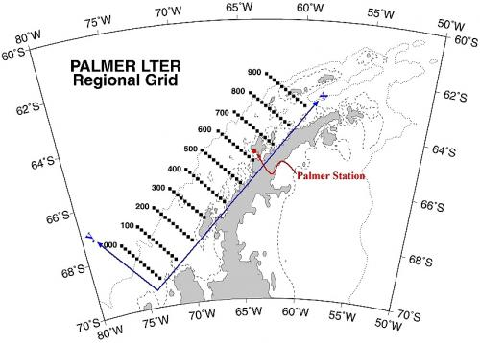

Figure 1. LTER regional grid, not including the extended grid (need to add), added in 2021.

Table 1. The four-character alpha code for each species.

|  |  |  |  |
| --- | --- | --- | --- |
| **SPECIES COMMON NAME** | **TAXA CODE** | **FAMILY** | **TAXON** |
| BLACK-BROWED ALBATROSS | BBAL | ALBATROSS | BIRD |
| GREY-HEADED ALBATROSS | GHAL | ALBATROSS | BIRD |
| LIGHT-MANTLED SOOTY ALBATROSS | LMSA | ALBATROSS | BIRD |
| SOOTY ALBATROSS | SOAL | ALBATROSS | BIRD |
| UNIDENTIFIED ALBATROSS | UNAL | ALBATROSS | BIRD |
| WANDERING ALBATROSS | WAAL | ALBATROSS | BIRD |
| SOUTHERN FULMAR | SOFU | FULMAR | BIRD |
| KELP GULL | KEGU | GULL | BIRD |
| ADELIE PENGUIN | ADPE | PENGUIN | BIRD |
| CHINSTRAP PENGUIN | CHPE | PENGUIN | BIRD |
| EMPEROR PENGUIN | EMPE | PENGUIN | BIRD |
| GENTOO PENGUIN | GEPE | PENGUIN | BIRD |
| MACARONI PENGUIN | MAPE | PENGUIN | BIRD |
| UNIDENTIFIED PENGUIN | UNPE | PENGUIN | BIRD |
| ANTARCTIC PETREL | ANPE | PETREL | BIRD |
| CAPE PETREL | CAPE | PETREL | BIRD |
| DIVING PETREL | DIPE | PETREL | BIRD |
| SOUTHERN GIANT PETREL | SGPE | PETREL | BIRD |
| NORTHERN GIANT PETREL | NGPE | PETREL | BIRD |
| SNOW PETREL | SNPE | PETREL | BIRD |
| UNIDENTIFIED PETREL | UNPT | PETREL | BIRD |
| WHITE-CHINNED PETREL | WCPE | PETREL | BIRD |
| BLUE PETREL | BLPE | PETREL | BIRD |
| ANTARCTIC PRION | ANPR | PRION | BIRD |
| FAIRY PRION | FAPR | PRION | BIRD |
| THIN-BILLED PRION | TBPR | PRION | BIRD |
| UNIDENTIFIED PRION | UNPR | PRION | BIRD |
| BLUE-EYED SHAG | BESH | SHAG/CORM | BIRD |
| AMERICAN (SNOWY) SHEATHBILL | AMSH | SHEATHBILL | BIRD |
| BROWN SKUA | BRSK | SKUA | BIRD |
| HYBRID SKUA | HYSK | SKUA | BIRD |
| SOUTH POLAR SKUA | SPSK | SKUA | BIRD |
| UNIDENTIFIED SKUA | UNSK | SKUA | BIRD |
| BLACK-BELLED STORM-PETREL | BBSP | STORM-PETREL | BIRD |
| UNIDENTIFIED STORM-PETREL | UNSP | STORM-PETREL | BIRD |
| WILSON’S STORM-PETREL | WISP | STORM-PETREL | BIRD |
| ANTARCTIC TERN | ANTE | TERN | BIRD |
| ARCTIC TERN | ARTE | TERN | BIRD |
| UNIDENTIFIED TERN | UNTE | TERN | BIRD |
| HOURGLASS DOLPHIN | HGDO | DOLPHIN | MAMMAL |
| UNIDENTIFIED DOLPHIN | UNDO | DOLPHIN | MAMMAL |
| CRABEATER SEAL | CRSE | SEAL | MAMMAL |
| (SOUTHERN) ELEPHANT SEAL | ELSE | SEAL | MAMMAL |
| (ANTARCTIC) FUR SEAL | FUSE | SEAL | MAMMAL |
| LEOPARD SEAL | LESE | SEAL | MAMMAL |
| ROSS SEAL | ROSE | SEAL | MAMMAL |
| UNIDENTIFIED SEAL | UNSE | SEAL | MAMMAL |
| WEDDELL SEAL | WESE | SEAL | MAMMAL |
| BLUE WHALE | BLWH | WHALE | MAMMAL |
| FIN WHALE | FIWH | WHALE | MAMMAL |
| HUMPBACK WHALE | HUWH | WHALE | MAMMAL |
| KILLER WHALE | KIWH | WHALE | MAMMAL |
| MINKE WHALE | MIWH | WHALE | MAMMAL |
| PILOT WHALE | PIWH | WHALE | MAMMAL |
| UNIDENTIFIED WHALE | UNWH | WHALE | MAMMAL |
| PTERAPOD | PTER | SNAIL | GASTROPOD |
| AMPHIPOD | AMPH | AMPHIPOD | INVERTEBRATE |
| CYLLOPSUS | CYLL | AMPHIPOD | INVERTEBRATE |
| EUSIRUS | EUSI | AMPHIPOD | INVERTEBRATE |
| GAMMERIDIAN | GAMM | AMPHIPOD | INVERTEBRATE |
| HYPEROCHE | HYPE | AMPHIPOD | INVERTEBRATE |
| CRYSYLOROPHIUS | CRYS | KRILL | INVERTEBRATE |
| EUPHUSIA SUPERBA | EUSU | KRILL | INVERTEBRATE |
| THYSANOESSA MACRURA | THMA | KRILL | INVERTEBRATE |

III. ISLAND AND PENGUIN CENSUS INSTRUCTIONS

A five day camp will take place at Avian Island during the cruise in which a large amount of data and samples will be collected in a short time frame (listed below). There are other field sites along the WAP that are of interest to C-013, some are visited more frequently than others. These are visited when time on the cruise allows. Talk with the PI before the cruise in order to make a list of priorities of places to visit during the cruise. The second priority to Avian is usually Charcot, which is the furthest south Adelie colony that we have studied. This is heavily influenced by sea ice concentration along the WAP and is usually reached around every 4-5 years.

List of other places of interest (see cheat sheets for more info about species/census/diets):

* Fish Islands
* Armstrong Reef
* Hugo Island
* Dione Island

**Avian Island**:

Avian Island is a small island just south of Adelaide Island. This camp will be put in as the ship transits south and either completes the 100 and 200 lines or conducts a process study in the area. Avian Island is a very important data set and the biggest reason we are on this cruise. It is a great example of a healthy, stable population of Adelies that is an important comparison with the data we collect at Palmer Station on a collapsing population of Adelies. Below is a list of tasks typically performed at Avian. Be sure to go over this with the PI prior to deployment to be sure there aren’t tasks that need to be added for the year. Be sure to take the data notebooks from the previous two years as reference.

* ADPE indicator colony census: 2, 3, 4, 5, 6, 7, 8, 9, 10, 11, 12, 13, 14, 15. Note: colonies 12, 13, 14, and 15 were added during the 2021-22 season.
* ADPE diets: 20 good samples with 50 measurable krill (can take up to >20)
* ADPE chick weights: These are to be done on the same day as Palmer Station team!
* Any ADPE tagging. Discuss with PI.(2 IGU and TDR packages 2023)
* ADPE Fecal Swabs and fecal collection on all diet birds and chick weights
* Sediment traps collected, processed, and reset on island
* GIPE nest and adult census
* SPSK census, during 2301: GPS SPSK nests if have time(do at same time as GIPE census)
* Marine mammal census
* SPSK Poo (20)
* ADPE chick feet (20)
* BESH census
* BESH Boli (20)
* BRSK observations and nest photos
* **FOR 2022-23 cruise get updated photos of ADPE indicator colonies.**

**Safety!:** You will do two check ins per day via sat phone. One will be with the ship and the other will be with the birders at Palmer. You will have two power sources for recharging of Iridium phone and radio batteries, a solar charger and small generator. Bring all the extra water, food, and gear that is allocated. It is a lot but worth having backup and extra of everything.

**BEFORE CAMP PUT IN:**

* Set up safety plan and check ins with MPC before offloading to AVI
  + Give MPC Iridium Sat Phone #
  + Make sure you have LMG, Palmer Station and Birder Hut Number
* Test Sat phones before departing

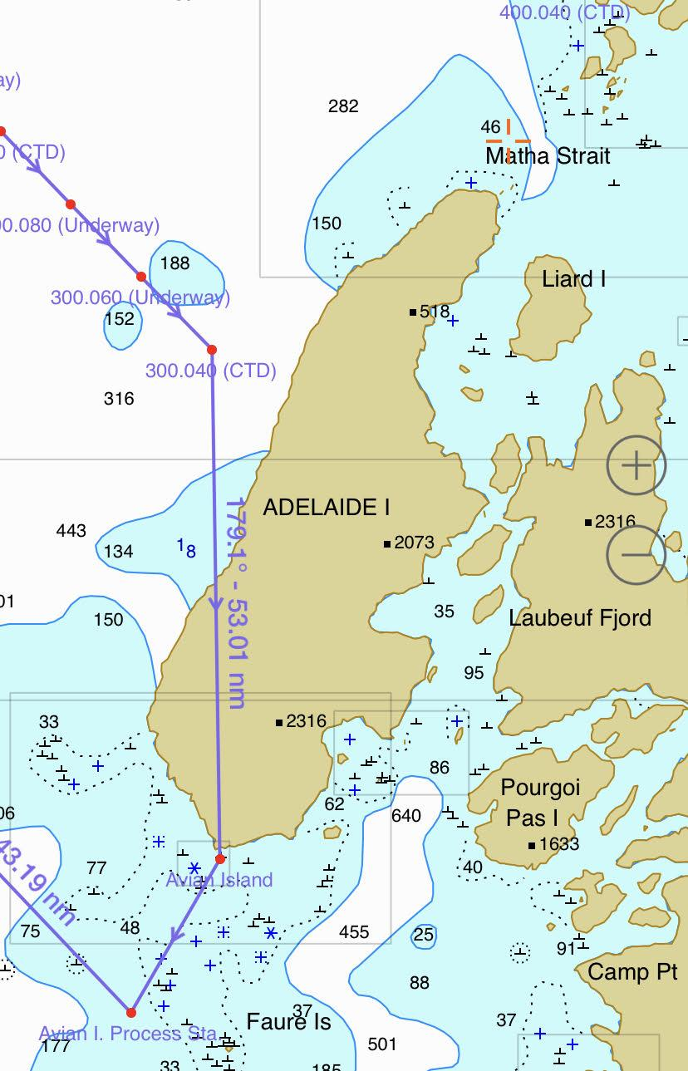

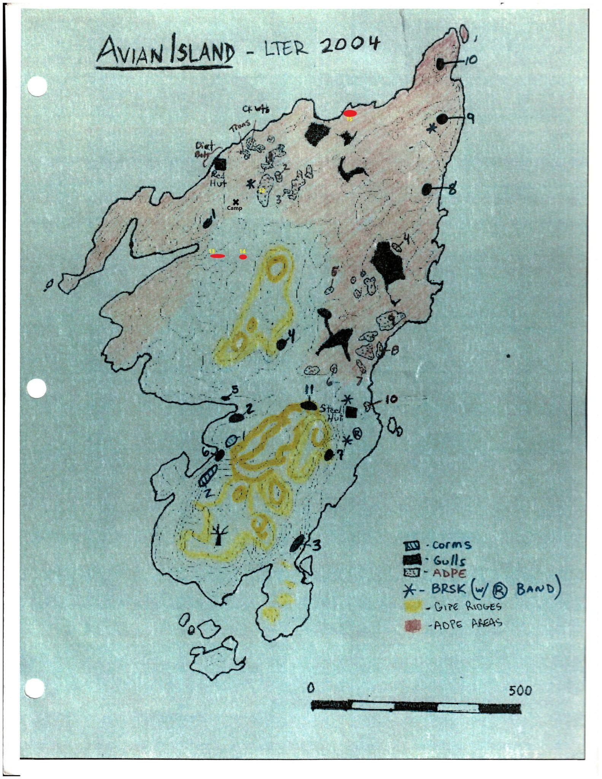

Avian Island colony map, obviously need to make a new one.

# HIGH DENSITY GRID / PICKET LINES (not done anymore, here for reference)

This survey was last conducted on LTER 1801 and can be conducted if there is extra time allocated to the Birder Team while in the Wauwerman Island/Palmer Deep area. A **high density grid** pattern beginning in the vicinity of Palmer Station (grid location 620.040) and extending south west is performed each summer cruise (Figure 1). The historical high density grid contains an area 10km by 20km broken into legs of 10km (East / West) and 2.5km (North / South) as illustrated in Figure 2. Each 10km leg is broken into two independent 40 minute-5km transects. Additionally, the latitude and longitude are recorded with time at the halfway or 2.5km into each 5km transect.

Bird observations are generally conducted as described in the ‘Transect’ section and are simultaneous with the acoustic monitoring, managed by the krill researchers. The ship speed during observations should be 4.5 – 5.0 knots, weather permitting. Given the necessity for vigilant bird observation simultaneous with data recording, it is recommended a second person is present to do all. Thus, the observer calls out time, taxon and behavior to the recorder while he/she also records transect header information at the beginning of each transect and latitude / longitude at midway points on the 5km legs. Event numbers are assigned to the bird and acoustic transects simultaneously and are called down by the recorder to the acoustics lab at the beginning of each transect. All indicated in Figure 1, CTDs are generally performed throughout the grid, though observations are only paused for the CTD conducted in the middle of the grid. Time permitting; a second high density grid pattern can be developed based on Adelie satellite telemetry data obtained from studies conducted at Palmer Station.

The **pickets line** bird observation and acoustic monitoring transects are performed in the same manner as described for the high density grid. The picket lines are two crescent shaped transects conducted 3.7 km and 10km from Torgersen Island. However, this description is included in the manual only for historical purposes. With the advent of satellite telemetry, we no longer need to conduct picket line obs.***Thank goodness.*** 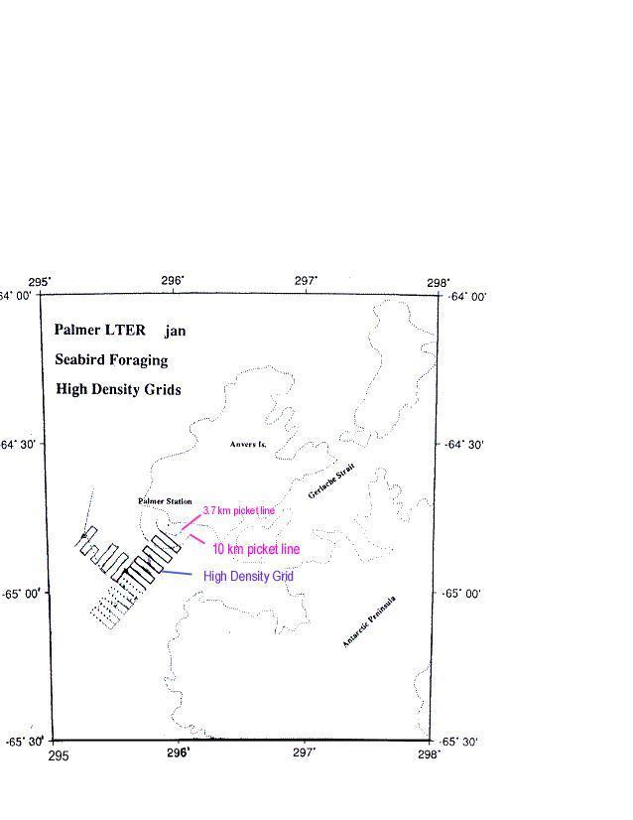

Figure 2. Seabird High Density Foraging Grids as relate to Anvers Island locations.

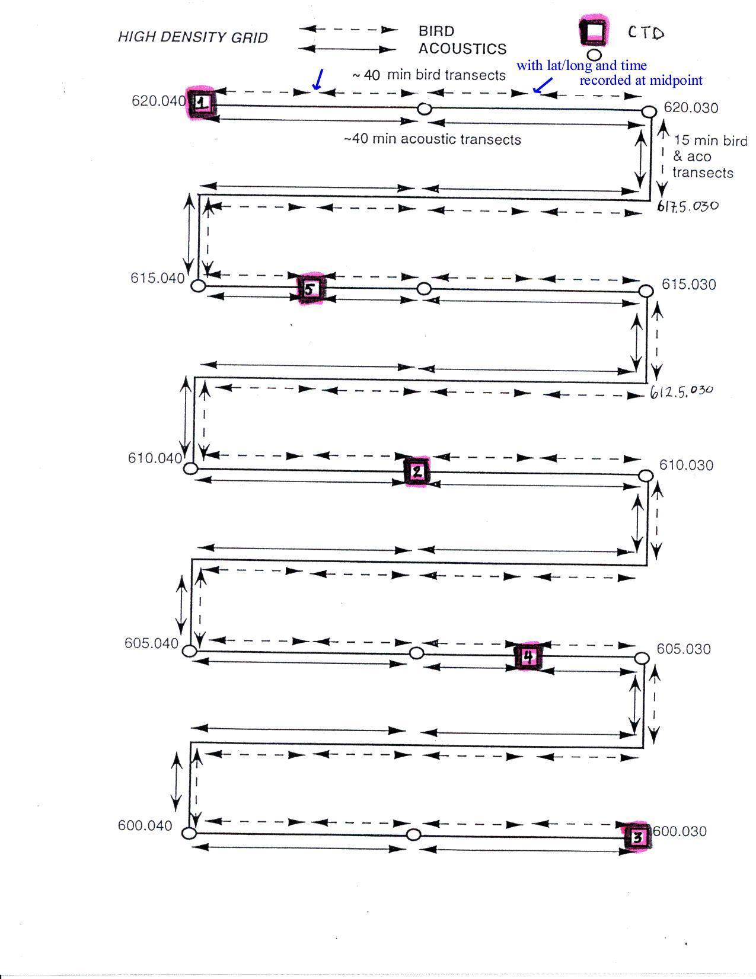

Figure 2. The historical high-density grid including grid numbers, bird and acoustic locations. Pink boxes denoting CTD indicate grid stations, open circles indicate underway stations. *This is just an example of a high-density grid used in the past, not the actual one we follow!*